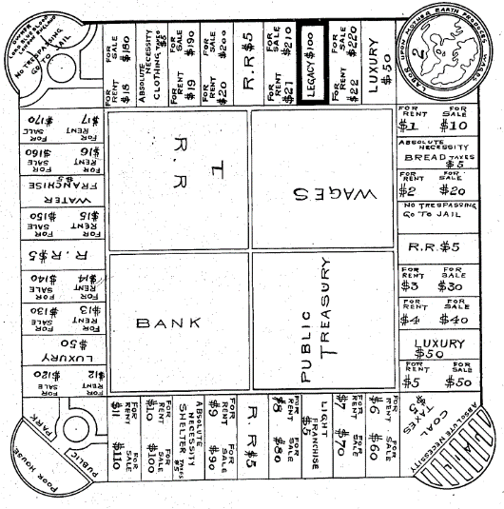Monopoly is an economics-focused 1935 board game by Charles Darrow. This was modified from the original work of Lizzie Magie’s 1906 “The Landlord’s Game”. [1] “The Landlord’s Game” (pictured below)[2] was created with the intention of promoting Georgism, an economic ideology that argues that rent derived from land should belong to everyone. [3] This game was used as an educational tool, and as Monopoly is a modified version of The Landlord’s Game, it has also been used to teach economics.[4]

The game involves players moving around a board sequentially, buying and developing property. The goal is to become the richest player and bankrupt other players through rent payments which is dependant on how developed the property is. The dice roll and chance/community chest add randomness and uncertainty to the game which helps to simulate the real world.

*“The Landlords Game”*

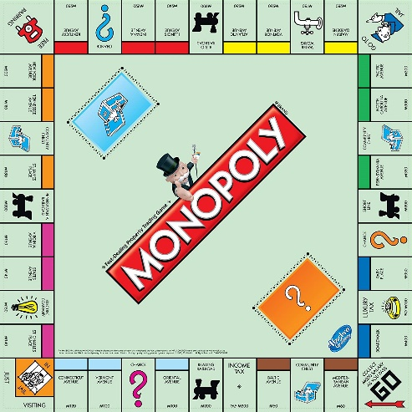There are many versions of Monopoly, with rule variations, cosmetic “dressing” changes or both. The size of the board is also not consistent across all boards, with “Monopoly Junior” being a rectangular board with 2 properties per set, and “Mega Monopoly” being a larger square board with 3/4 properties per set. Pictured below is the 2013 standard edition of monopoly [5], the standard edition has changed very little over its 80+ year history. Even within the same game of monopoly, participants will diverge from the normal rules by introducing “house rules”, unofficial rules (some of which were incorporated into a 2014 house rules edition of the game[6]) which alter gameplay usually in a way that increases overall playtime. Some examples of the most commonly implemented house rules include collecting double the amount for passing Go when landing on that space, not allowing rent collection while the property owner is in Jail, awarding players for landing on free parking, rewarding a player for rolling a 2 (double 1’s/”snake eyes”) and requiring a full lap around the board before allowing purchasing property [6]

*2013 Monopoly board (Copyright Hasbro)*

Monopoly has been shown by a study to be an efficient tool in education, having been used to teach financial accounting with a modification of the rules.[7] By modifying the board layout, the rules and the dressing Monopoly can be altered to appeal to anyone and to teach a wide variety of topics. The task that I have set for myself for this capstone project is to create “Monopoly Maker”, where players can play, create and customise boards of all the aspects of monopoly to create their own Monopoly version curated to suit them or as a teaching tool. Alternatively, players could utilise the pre-set boards based on the standard Monopoly boards.

[1] Vinny Montag, “Refugeoly, Building a Serious Game through refugee testimonies”, September 15 2020. Available: <https://dl.acm.org/doi/pdf/10.1145/3402942.3409615>

[2] L. J. Magie, “Game Board”, U.S. Patent 748 626, January 5 1904

[3] Jane McNab and Jacqueline Tuck, “How the reputation of Georgists turned minds against the idea of a land rent tax”, 2013, Available: <https://web.archive.org/web/20140812144900/http://www.business.uwa.edu.au/__data/assets/pdf_file/0019/2325322/Jane-McNab-Jacqueline-Tuck-Final-b-HETSA-Paper-2013.pdf>

[4] E. J. Dodson (2011, Dec.). How Henry George's Principles Were Corrupted Into the Game Called Monopoly [Online]. Available: <https://www.henrygeorge.org/dodson_on_monopoly.htm>

[5] Top down view of 2013 standard Monopoly board, Photographed by Hasbro

[6] Associated Press (2014, Apr. 4) $500 for rolling double ones and $400 for landing on Go: The new Monopoly 'house rules' made up by fans of the Hasbro game [Online]. Available: <https://www.dailymail.co.uk/femail/article-2596909/Hasbro-picks-5-house-rules-new-Monopoly-set.html>

[7] S. B. Shanklin and C. R. Ehlen, Using The Monopoly® Board Game As An Efficient Tool In Introductory Financial Accounting Instruction, 2007. Available: <https://www.clutejournals.com/index.php/JBCS/article/download/4852/4944>